CSI REPORT

REPORT ON WEB DESIGNING WORKSHOP
THE CVSRCSI chapter organized a workshop on “WEB DESIGNING” from 22nd to 24th Aug 2013. This workshop was conducted in collaboration with zeta interactive system by Y. Chandramohan Reddy for the 2nd year students of CSE.
Profile of trainer:

Mr. Y.Chandramohan Reddy has more than three years of experience in web designing presently working in zeta interactive systems as software engineer

The workshop main objectives:

•To understand the basic concepts for creating website;
•To be able to create a simple web site;
•To have knowledge for updating information on the web site.
Activities included both formal presentations and practical work
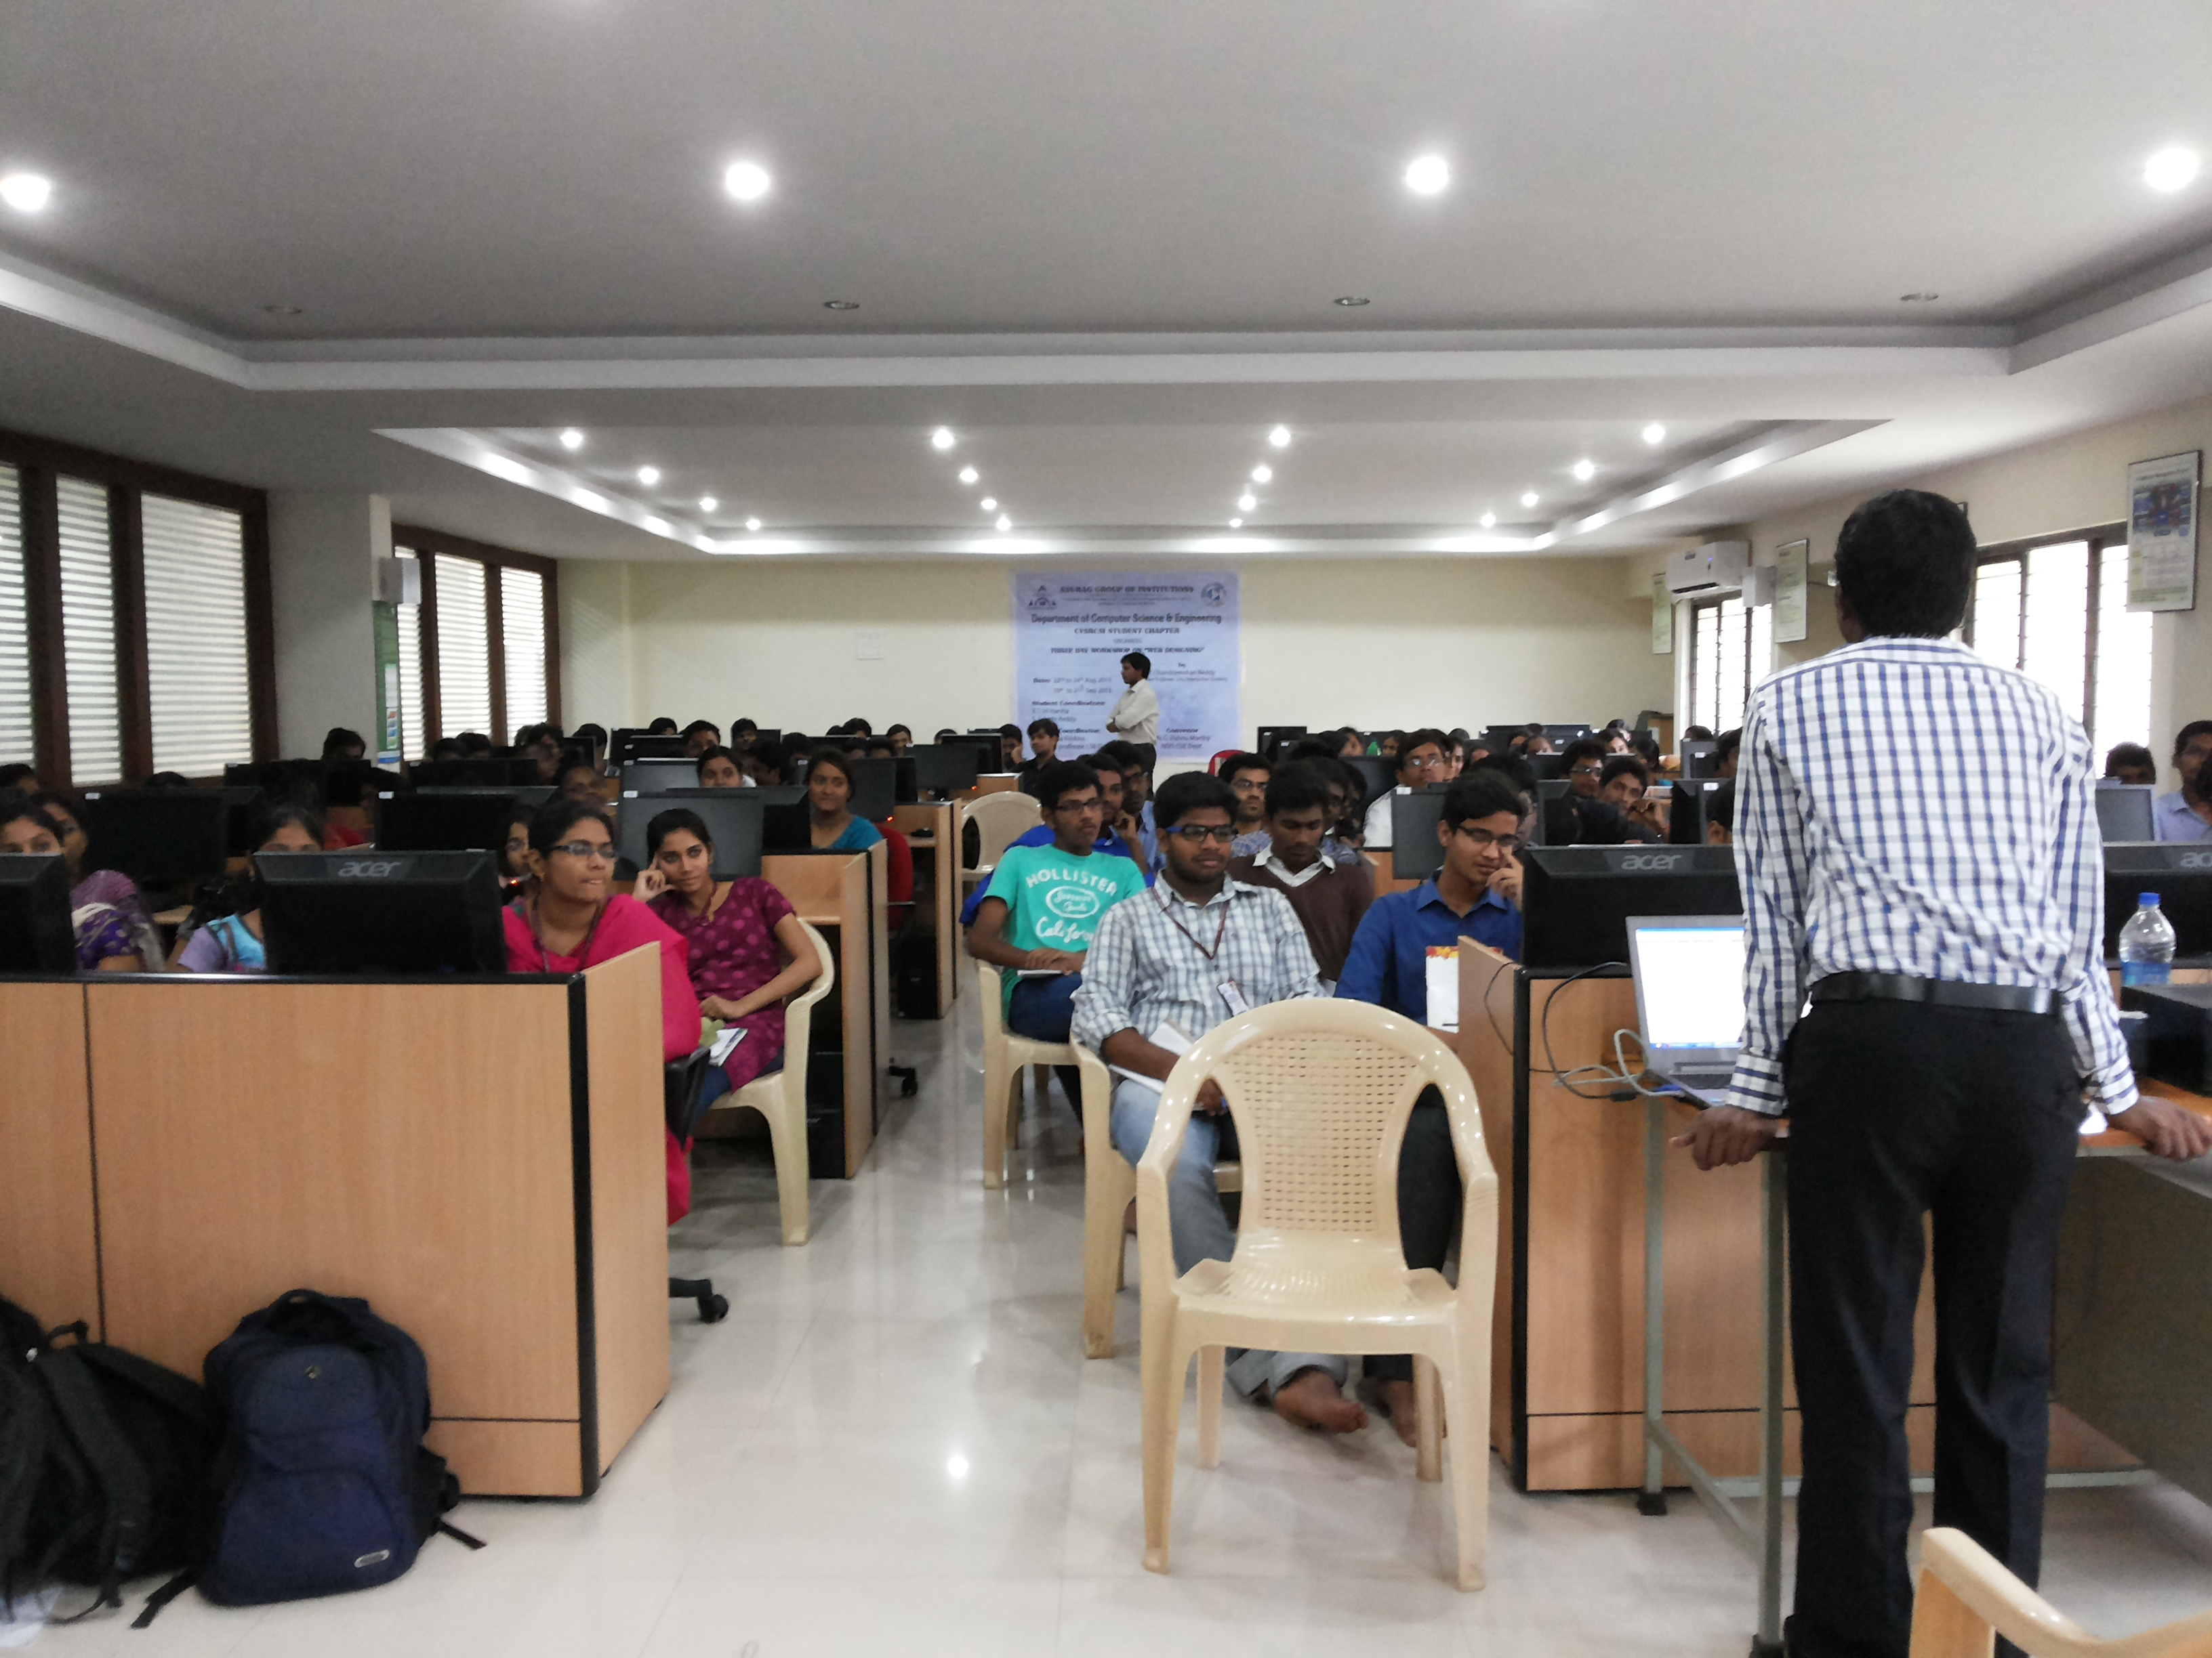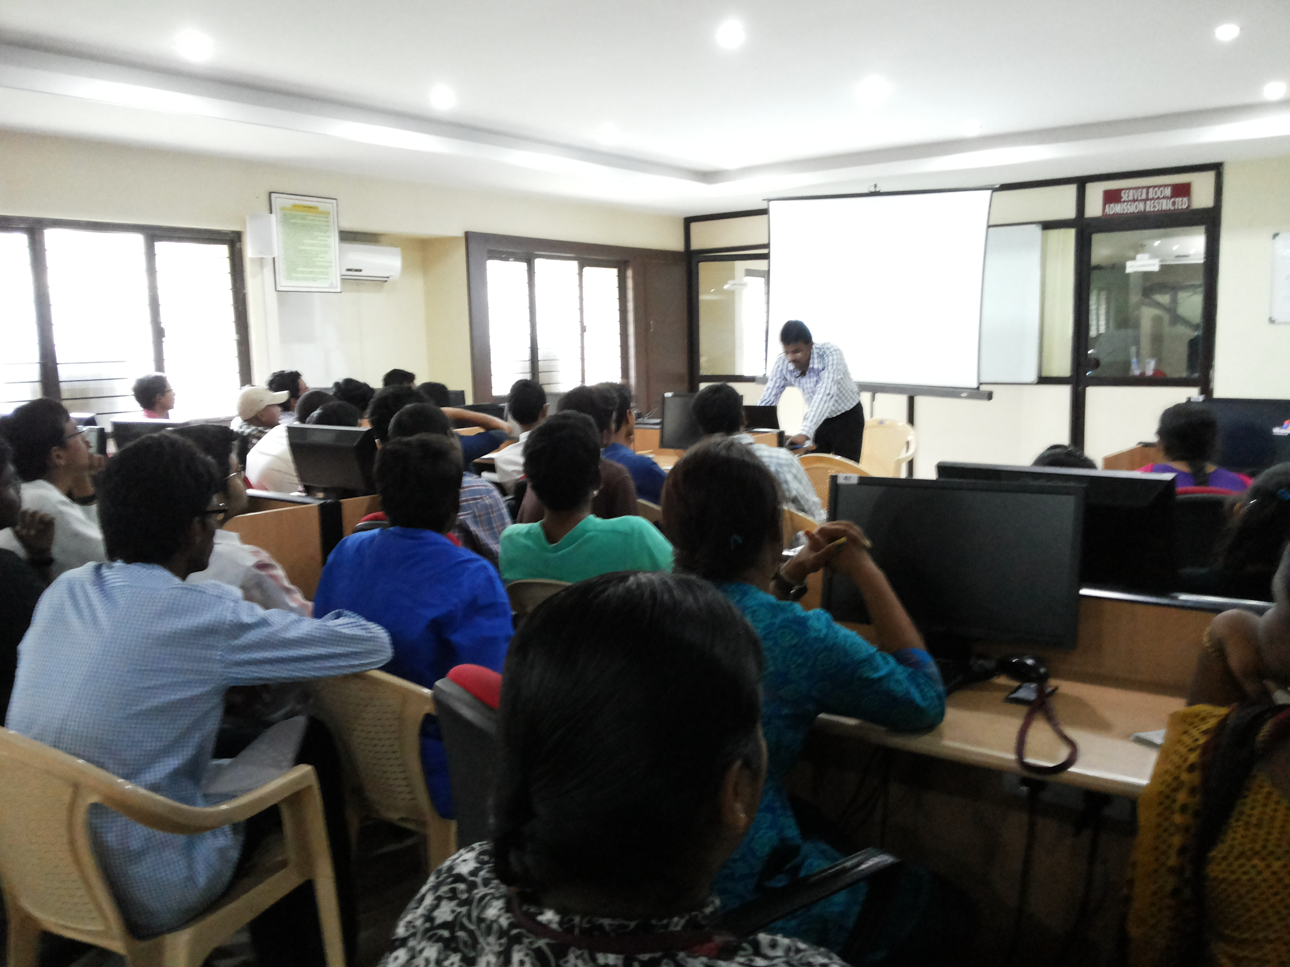
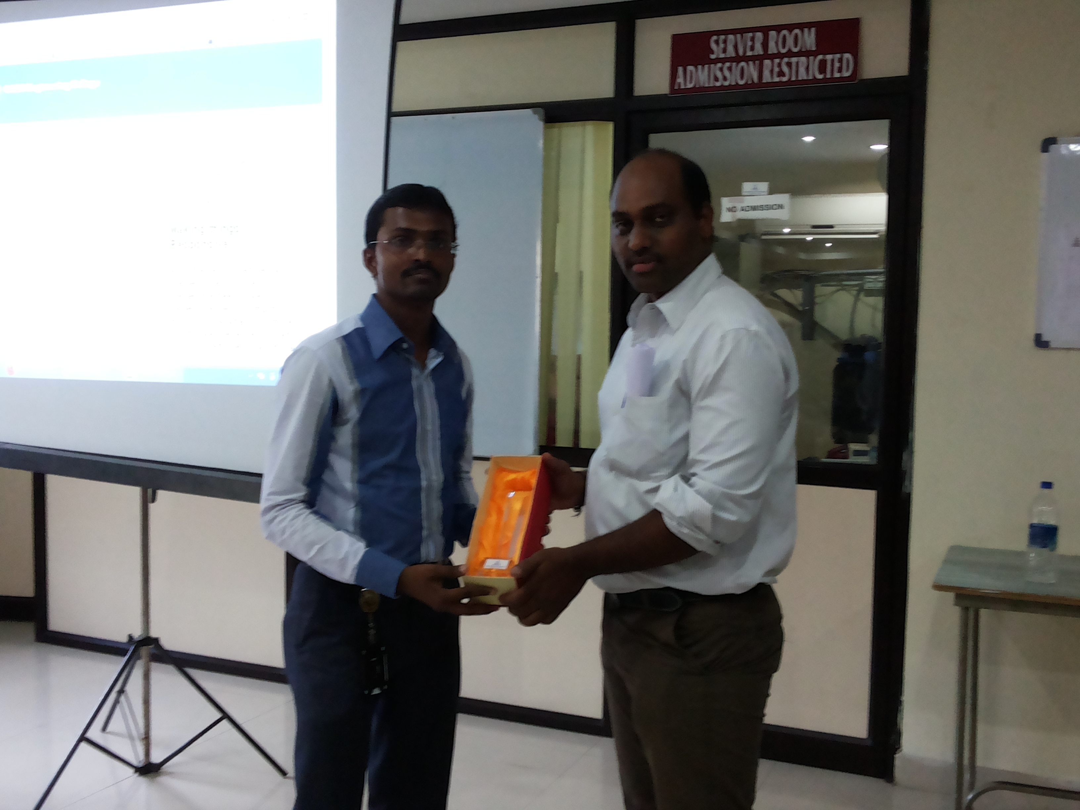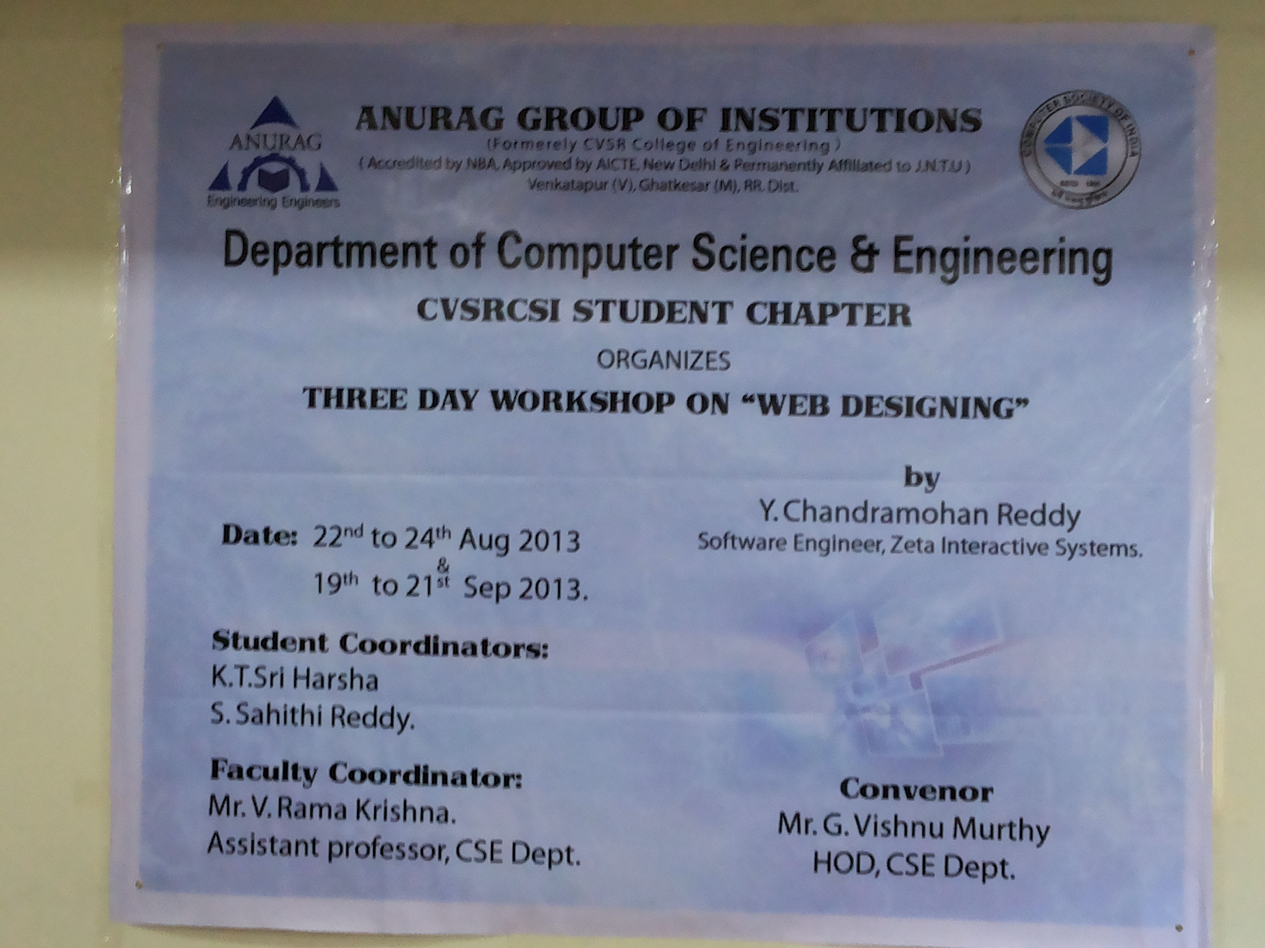

The First session was conducted on 22nd Aug 2013 this session emphasised on the basics of Web Designing and enlightened the students with various terminologies involved in Web Designing .
The Second session was covered basics of HTML and CSS .
The Third session was conducted on 23rd Aug 2013 this session covered various Client Side scripting languages such as JAVA SCRIPTS, jquery.
The fourth session discussed on server side scripting PHP.
The fifth session was conducted on 24th Aug 2013 this session covered web standards, hosting the website
2nd year of CSE students had attended the workshop. Total 120 members attended. He explained excellently and simultaneously practical session was conducted.
All the sessions were presented in an excellent and in a pleasant way. The workshop ended on 24th Aug 2013

A REPORT ON DIGITAL IMAGE PROCESSING WORKSHOP
A seminar on “ DIGITAL IMAGE PROCESSING” was conducted on 25th
AND 26th February 2013 in Anurag Group of Institutions .
Dr.G.R.Simha professor(ETC) of Shri Shankaracharya Technical Campus delivered the seminar on day1 i.e 25th February 2013 morning session was from 10:00 pm to 12:30 pm. The seminar was started with the introduction to the concepts of “motivational skills”&”top hiring skills” in which he covered
- Development of multiple intelligence
- How to learn
- Continuous quality improvement
- Success process
Then the introduction to Image Processing was started in which the definition ,key stages in image processing such as sampling ,quantization,categories of image processing and applications were covered.
The second session was begun in the afternoon at 1:30pm.This session was started with the concepts of filtering,morphological processing,segmentation,image enhancement.Then Dr.Simha gave a detailed information on “what a research paper should contain?”with an example of a research paper by his student under his guidence on agriculture.The use of image processing in Cancer Detection was explained briefly.
On day2 i.e 26th Feb 2013,the morning third session started with the execution of commands in MATLAB such as read,write,resize,display,histrogram ,cropping image etc. A program to read an image and calculating mean,variance values of the image was executed.
The fourth session started at 2:00 pm. The main concept of this session was on writing a research paper. This session included where to download the research papers, how to begin writing the research paper. Dr.Simha has written a sample research paper and gave an example of his experiences while publishing paper in IEEE ending this session.
Finally the seminar on DIGITAL IMAGE PROCESSING by Dr.G.R.Simha was a motivation for many students who are willing to do research .The concepts of DIP were explained with real-time examples, making it easy to learn. Overall the seminar was satisfactory.
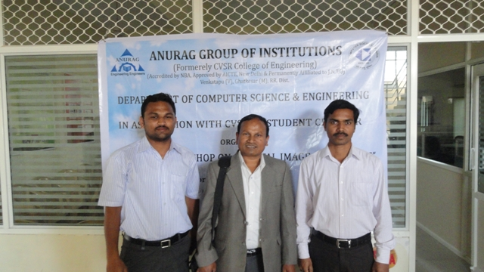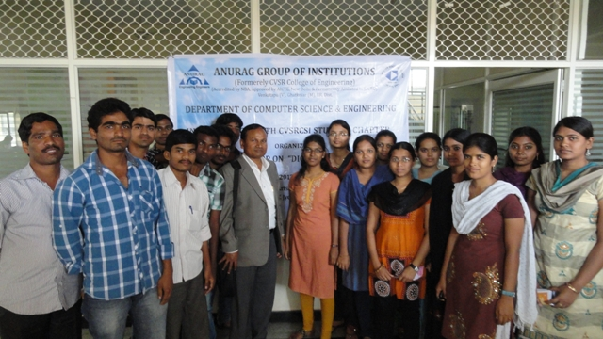

REPORT ON WEB DESIGNING WORKSHOP
THE CVSR-CSI chapter organized a workshop on “WEB DESIGNING” on 15th February and 16th February 2013. This workshop was conducted by Rainbow finishing school for the 2nd year students of CSE & IT .
The First session was conducted on 15th February 2013 this session emphasised on the basics of Web Designing and enlightened the students with various terminologies involved in Web Designing .
The Second session was about various scripting languages such as JAVASCRIPTS which are used in Web Designing,In this session basics of CSS and PhotoShop were also covered.
The Third session was conducted on 16th February 2013 in this session was about HTML and FLASH, this session illustrated the various aspects of HTML and FLASH.
The Fourth session was conducted on 16th February 2013 this session showed students the different phases in FILE HOSTING.
All the sessions were presented in an excellent and in a pleasant way.The workshop ended on 16th February 2013.
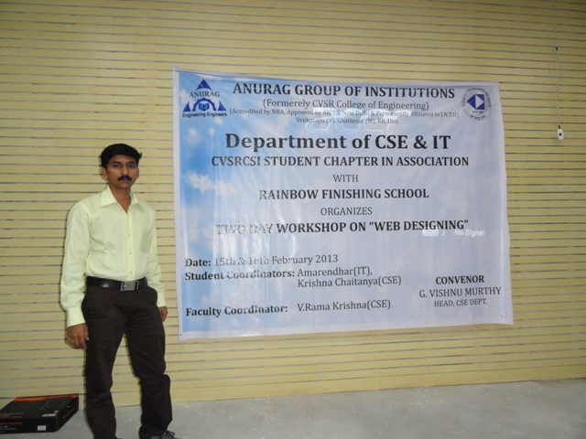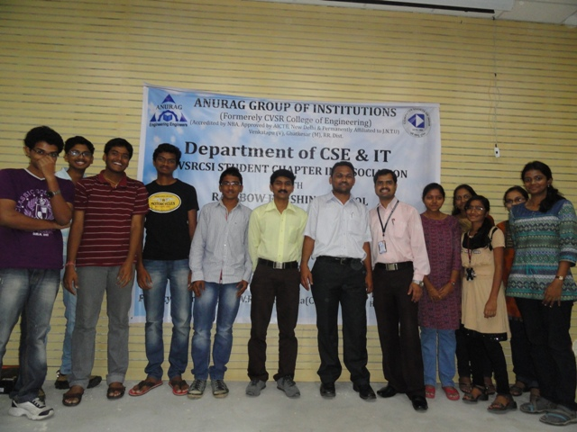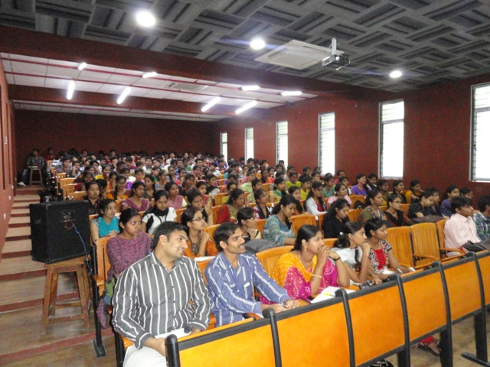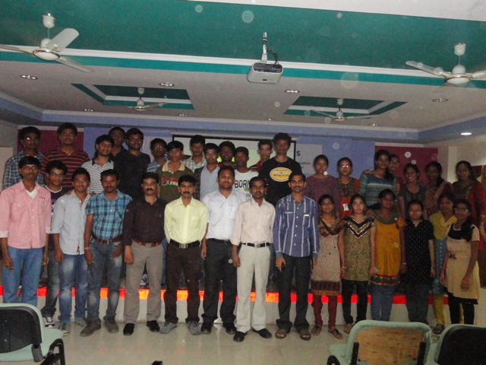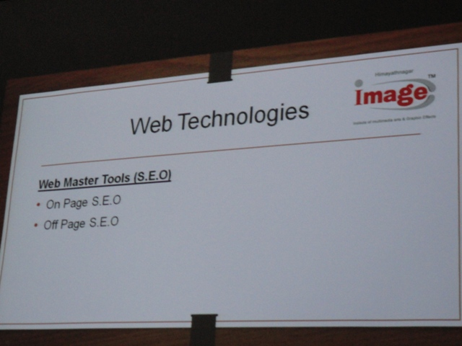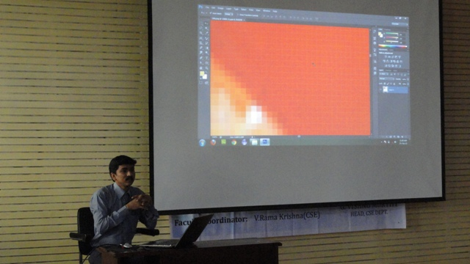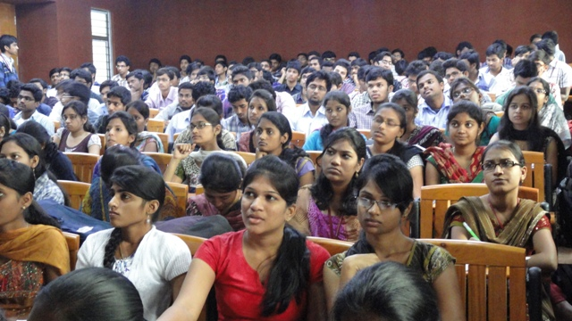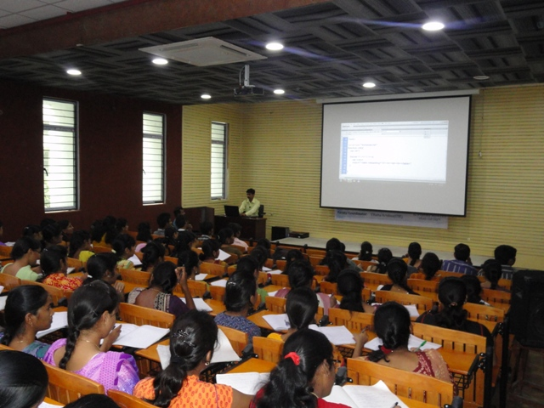
CSI- Chapter Inaguration:
Inauguration of CVSR-CSI student chapter on 22nd December 2010.Now, we have the opportunity to be a part of this distinguished fraternity through our CSI Student Chapter with 346 members.
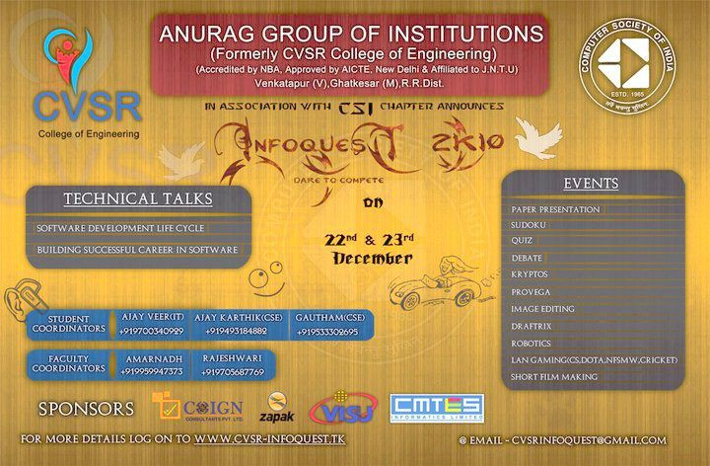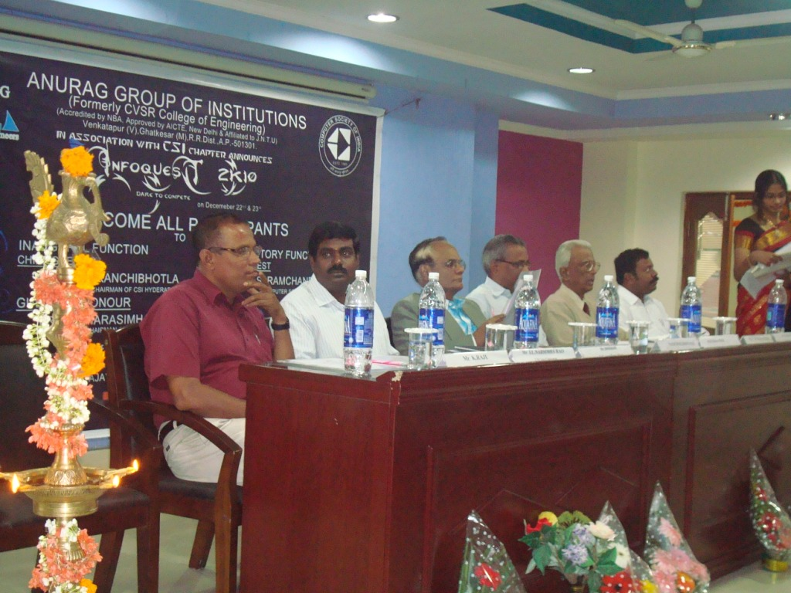

Adobe Flex Workshop :
The CVSR-CSI student chapter organized a workshop on “Adobe Flex” on 25th Feb and 1st March 2011.It is an interactive practical session of 7 hours. This workshop was conducted by the Genesis Software Solutions, Hyderabad. They had tie up with the Adobe, Bangalore. Adobe is providing participation certificates for the students & two faculty members who attended the workshop. Also they are offering original Adobe Flex software CD for the college and also for the attended students with lifetime validity.
The first session was conducted on 25th Feb, 2011 by Mr.Shiv Sharan, Genesis Software solutions. The workshop was started at 9.00am & continued till 4.00pm for both the days.
III year and II year of CSE and IT students had attended the workshop. In the first session, total 96 members attended. He explained excellently and simultaneously practical session was conducted. The session2 was conducted on 1st March; 2011.The students were so enthusiastic to attend for the workshop.
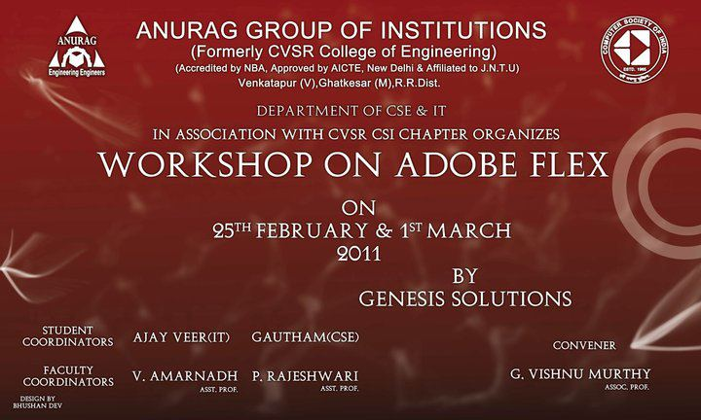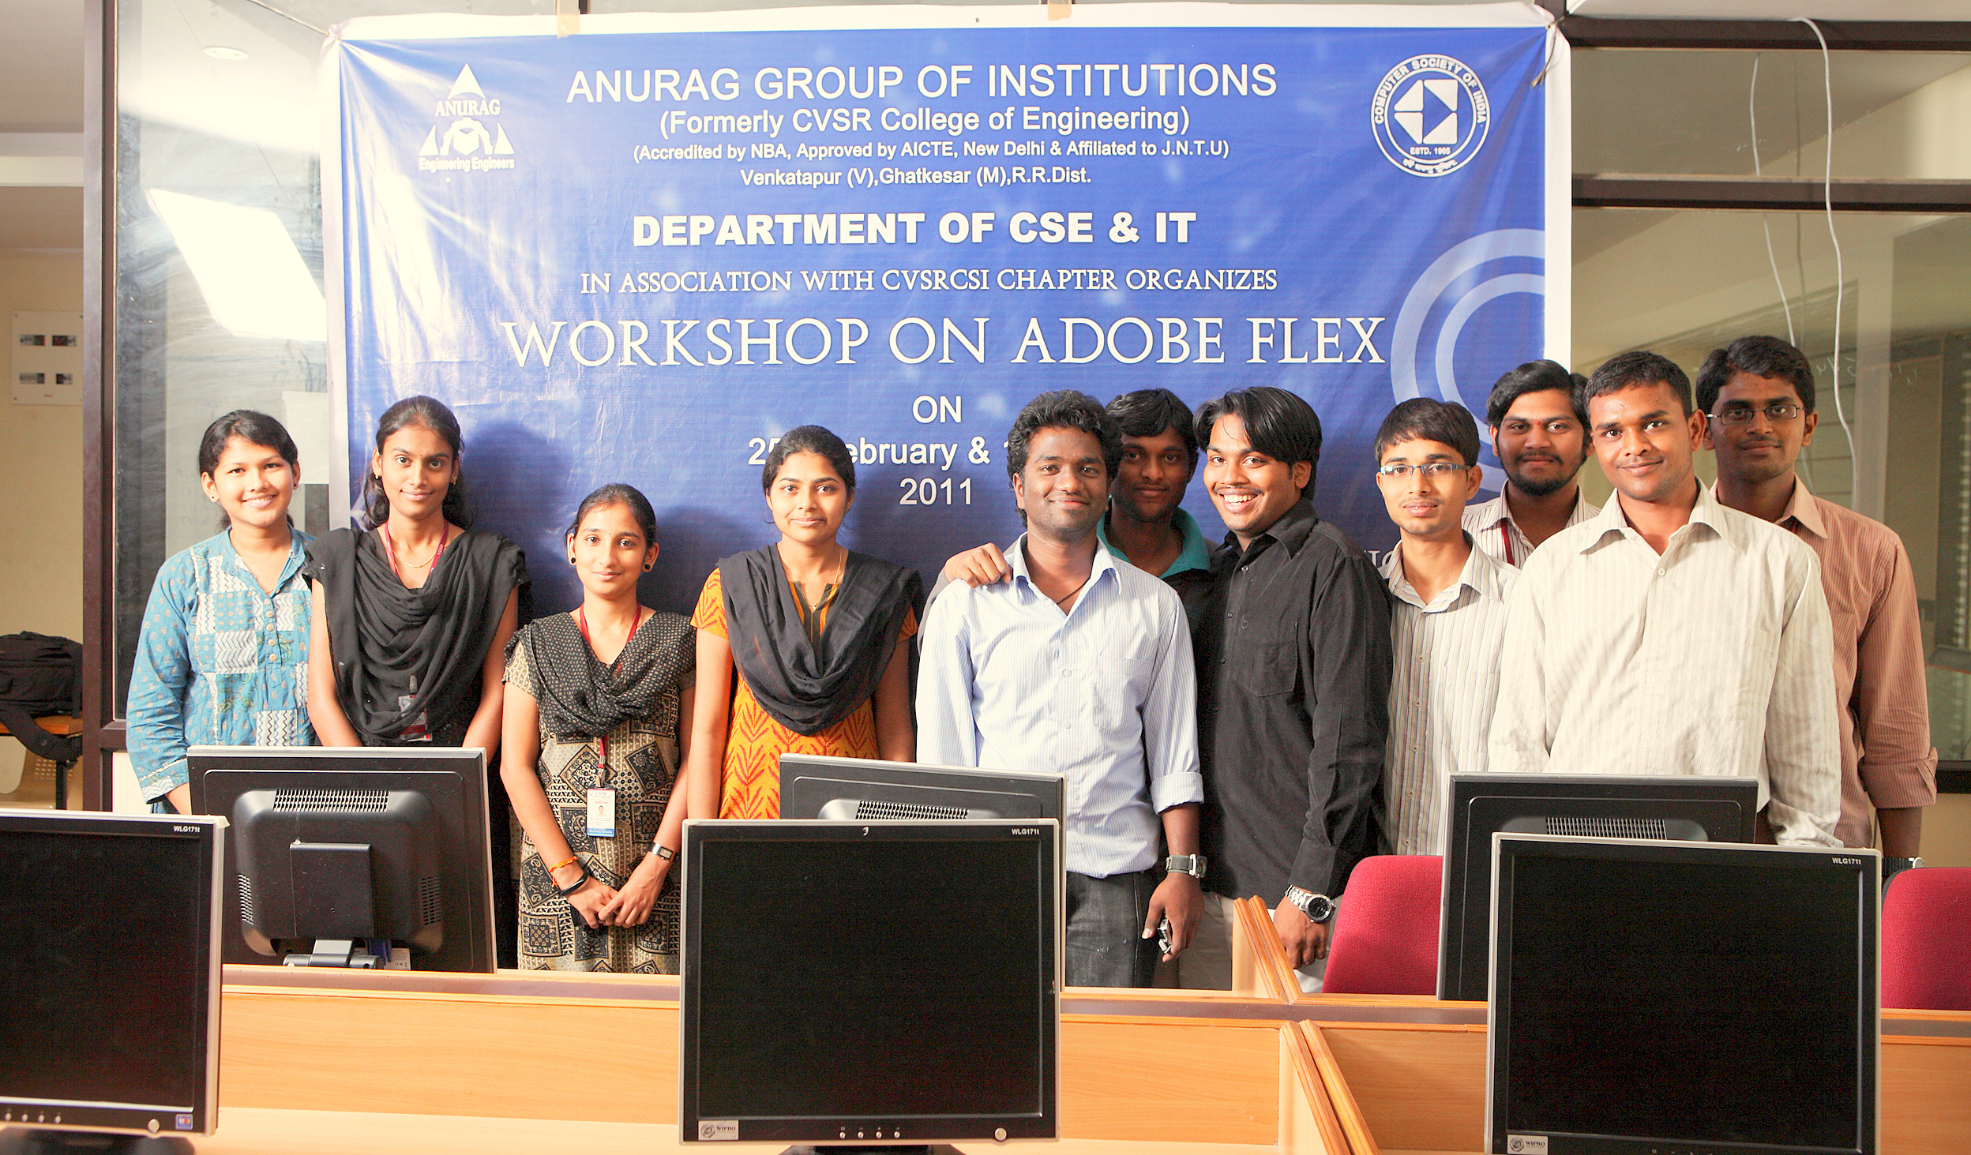
Cloud Computing Workshop:
The CVSR-CSI student chapter organized a workshop on “CLOUD COMPUTING” on 26th & 27th August 2011.It is an interactive practical session of 7 hours. This workshop was conducted by the COING EDU & IT SERVICES PVT. LIMITED. They provided participation certificates for the students & two faculty members who attended the workshop.
The first session was conducted on 26th Aug, 2011 by Mr.Durga Naveen, COING EDU & IT SERVICES PVT. LIMITED CEO. The workshop was started at 9.00am & continued till 4.00pm for both the days.
III year and II year of CSE and IT students had attended the workshop. In the first session, total 210 members attended. He explained excellently and simultaneously practical session was conducted. The session2 was conducted on 27th august 2011.The students were so enthusiastic to attend for the workshop.
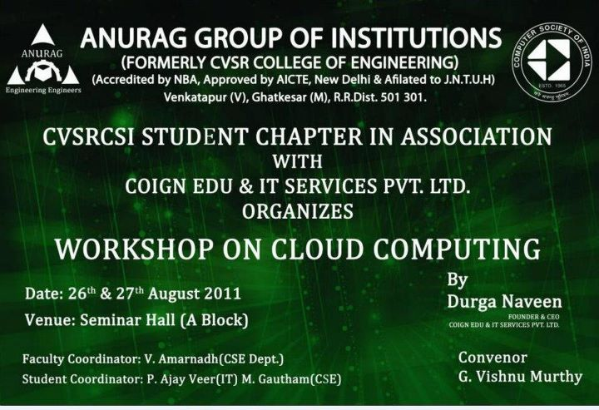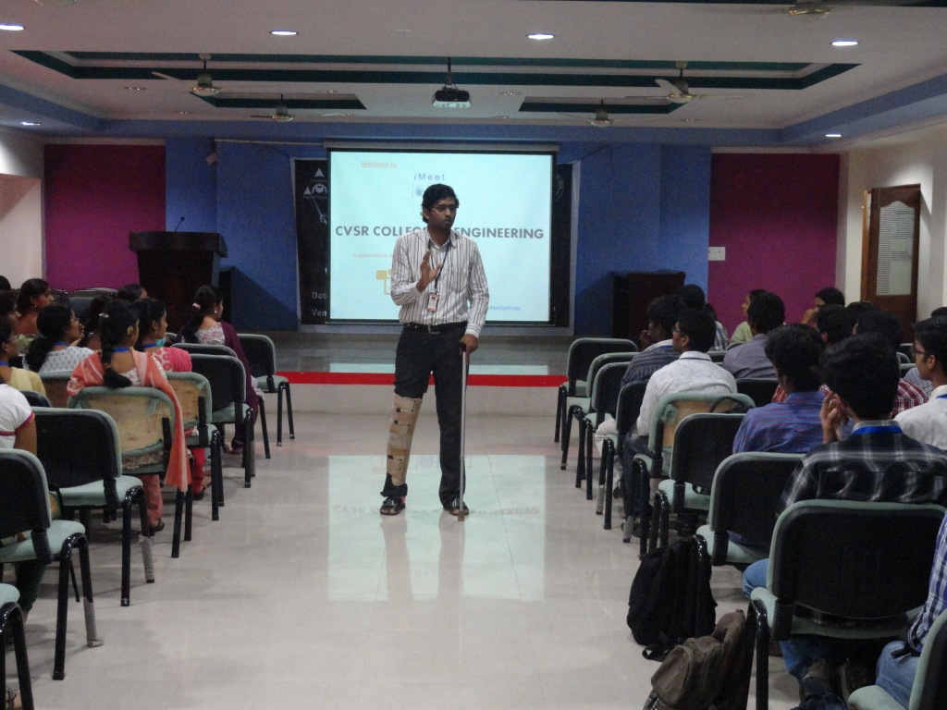

Adobe Photoshop Workshop:

The CVSR-CSI student chapter organized a workshop on “ADOBE PHOTOSHOP” on 17th18th & 19thnovember2011.It is an interactive practical session of 7 hours. This workshop was conducted by RAINBOW FINISHING SCHOOL. They providedparticipation certificates for the students & four faculty members who attended the workshop.
The first session was conducted on 17th Aug, 2011 by Mr.SRINIVASA CHARY RAINBOW FINISHING SCHOOL TEAM LEADER,. The workshop was started at 9.00am & continued till 4.00pm for 3 days.
III year and II year of CSE and IT students had attended the workshop. In the first session, total 280 members attended. He explained excellently and simultaneously practical session was conducted. The session2 AND session3 was conducted on 18th& 19thnovember 2011.The students were so enthusiastic to attend for the workshop.


