

Department of Computer Science & Engineering

Course Name : SOFTWARE PROJECT MANAGEMENT

Course Number : A58043

Course Designation: Elective

Prerequisites : C Programming,
Object Oriented Analysis and Design

Software Engineering

IV B Tech – II Semester

(2016-2017)

G.Lavanya
Asst Prof
Course Coordinator

SYLLABUS
Unit – I | Introduction to software project management: Introduction, importance of software project management, definition of project, software project vs other projects, contract management and technical project management, plans, methods, methodologies, Categorization of software project, definition of management, problems, setting of objectives, stakeholders, the business case, requirement specification, management control.  Stepwise: overview of project planning: Introduction, selection of projects, identification of project scope, objectives infrastructure, products and activities, activity risks. Analysis of project characteristics, estimation of effort for each activity, allocation of resources, review/publicize plan/execute plan.
Unit – II | Programme management and project evaluation: programme management, management of allocation of resources within a programme , strategic programme management, creating a programme management, aids to programme management, benefits, evaluation of individual project’s, technical assessment, cost benefit analysis, evaluation techniques, cash flow forecasting, risk evaluation.  Selection of an appropriate project approach: choosing technologies, technical plan content list, choice of process models(waterfall, v-process, spiral), structure vs speed of delivery, software prototyping and categorizing, incremental delivery, dynamic system development method, extreme programming, managing iterative process and selecting appropriate process model.
Unit – III | Software effort estimation: applications and its problems, the basis of software estimation, and effort estimation techniques (expert judgment, estimation by analogy, and Albrecht function point analysis, function points.  Activity Planning: objectives, plan, project schedules, projects and activities(sequencing and scheduling),k network planning models, formulating the network models, adding time dimension, far ward and backward pass , identifying the critical path, activities.
Unit – IV | Risk Management: risk and its categories, framework (identification, assessment, planning, and management), evaluating risks to the schedule, applying the PERT techniques, monte carlo simulation, and critical chain concepts.  Resource Allocation: Nature, identifying requirements, scheduling, creating critical paths, counting costs, publishing, cost schedule, scheduling sequence.
Unit – V | Monitoring and control: creating framework, collecting data, visualizing progress, cost monitoring, earned value analysis, prioritizing monitoring, change control.  Managing contracts: ISO 12207 approach, supply process, types, stages, typical terms of a contract, contract management, acceptance.  Managing people and organizing teams: organizational behaviour, selecting the right person, instruction and best methods, motivation, Oldham-Hackman job characteristics working in groups, becoming a team, decision making, leadership, organizational structures, dispersed and virtual teams, influence of culture, stress, health and safety.  Software Quality: importance, definition, measures, plans, techniques used for enhancing, External standards.

Text Books:
1. Software Project Management, Bob Hughes and Mike Cotterell: Tata McGraw-Hill, 4TH Edition.
Reference Books:
1. A Guide To The Project Management Body Of Knowledge (PMBOK Guide).
Newtown Square, Pa. : Project Management Institute, Inc., 2004. Print.
2. Software Project Management, Walker Royce: Pearson Education, 2005.
3. Software Project Management, Joel Henry, Pearson Education.
4. Software Project Management in practice, Pankaj Jalote, Pearson Education.

Websites References
https://www.classle.net/#!/classle/large-content/software-project-managment-lecture-slides/
https://at-web1.comp.glam.ac.uk/staff/dwfarthi/projman.htm
http://qiscetmca09.blogspot.in/2011/06/download-software-project-management-by.html

Time Table

Room No: 212/A-Block W.E.F: 21/11/2016
TO: 23/03/2016

Class Hour  Time | 1 | 2 | 3 | 4 | 12:20 – 1:00  LUNCH BREAK | 5 | 6 | 7
Class Hour  Time | 9:00 -09:50 | 09.50 –10:40 | 10:40 –11:30 | 11:30 – 12: 20 | 12:20 – 1:00  LUNCH BREAK | 1:00 – 1:50 | 1:50 – 2:40 | 2:40 – 3:30
MON | IV-B |  |  |  | 12:20 – 1:00  LUNCH BREAK | IV-B
TUE |  |  | IV-B | IV-B | 12:20 – 1:00  LUNCH BREAK
WED |  |  |  | IV-B | 12:20 – 1:00  LUNCH BREAK
THU |  |  |  |  | 12:20 – 1:00  LUNCH BREAK
FRI |  |  |  |  | 12:20 – 1:00  LUNCH BREAK
SAT

PROGRAM EDUCATIONAL OBJECTIVES (PEO’s)

PEO1 | The Graduates are employable as software professionals in reputed industries.
PEO2 | The Graduates analyze problems by applying the principles of computer science, mathematics and scientific investigation to design and implement industry accepted solutions using latest technologies.
PEO3 | The Graduates work productively in supportive and leadership roles on multidisciplinary teams with effective communication and team work skills with high regard to legal and ethical responsibilities.
PEO4 | The Graduates embrace lifelong learning to meet ever changing developments in computer science and Engineering.

Programme Specific Outcomes (PSOs)
- Professional Skill: The ability to understand, analyze and develop software solutions.
- Problem-Solving Skills: The ability to apply standard principles, practices and strategies for software development.
- Successful Career: The ability to become Employee, Entrepreneur and/or Life Long Learner in the domain of Computer Science.

PROGRAM OUTCOMES (PO’s)

1. Engineering knowledge: Apply the knowledge of mathematics, science, engineering fundamentals, and an engineering specialization to the solution of complex engineering problems.
2. Problem analysis: Identify, formulate, review research literature, and analyze complex engineering problems reaching substantiated conclusions using first principles of mathematics, natural sciences, and engineering sciences.
3. Design/development of solutions: Design solutions for complex engineering problems and design system components or processes that meet the specified needs with appropriate consideration for the public health and safety, and the cultural, societal, and environmental considerations.
4. Conduct investigations of complex problems: Use research-based knowledge and research methods including design of experiments, analysis and interpretation of data, and synthesis of the information to provide valid conclusions.
5. Modern tool usage: Create, select, and apply appropriate techniques, resources, and modern engineering and IT tools including prediction and modeling to complex engineering activities with an understanding of the limitations.
6. The engineer and society: Apply reasoning informed by the contextual knowledge to assess societal, health, safety, legal and cultural issues and the consequent responsibilities relevant to the professional engineering practice.
7. Environment and sustainability: Understand the impact of the professional engineering solutions in societal and environmental contexts, and demonstrate the knowledge of, and need for sustainable development.
8. Ethics: Apply ethical principles and commit to professional ethics and responsibilities and norms of the engineering practice.
9. Individual and team work: Function effectively as an individual, and as a member or leader in diverse teams, and in multidisciplinary settings.
10. Communication: Communicate effectively on complex engineering activities with the engineering community and with society at large, such as, being able to comprehend and write effective reports and design documentation, make effective presentations, and give and receive clear instructions.
11. Project management and finance: Demonstrate knowledge and understanding of the engineering and management principles and apply these to one’s own work, as a member and leader in a team, to manage projects and in multidisciplinary environments.
12. Life-long learning: Recognize the need for, and have the preparation and ability to engage in
independent and life-long learning in the broadest context of technological change.

Course Outcomes
At the end of the course the student will be able to:
1. Apply the practice of project management in delivering of projects.
2. Evaluate the project against strategic, technical and economic criteria.
3. Analyze various effort estimation techniques and activity planning.
4. Identify risks involved in the Resource scheduling by using risk management techniques.
5. Analyze project monitoring and controlling procedures to manage contracts to implement quality software.

POS mapping with PEOS:
Programme Educational Objectives (PEOs) | PO1 | PO2 | PO3 | PO4 | PO5 | PO6 |  | PO7 |  | PO8 |  | PO9 |  | PO10 |  | PO11 |  | PO12
PEO1 | X | X | X | X | X |  | X |  | X |  | X |  | X |  | X |  | X | X
PEO2 | X | X | X | X | X |  | X |  | X |  | X |  | - |  | - |  | X | X
PEO3 | - | X | X | - | - |  | X |  | - |  | X |  | X |  | X |  | X | -
PEO4 | - | - | X | X | X |  | X |  | X |  | X |  | - |  | - |  | X | X

MAPPING OF COURSE OUT COMES WITH PO’s
Programme Educational Objectives (PEOs) | PO1 | PO2 | PO3 | PO4 | PO5 | PO6 | PO7 | PO8 | PO9 | PO10 | PO11 | PO12
CO1 |  | x | x |  |  | x |  | x
CO2 | x | x | x | x | X | x | x | x |  |  | x
CO3 |  |  |  |  |  | x | x
CO4 |  | x | x |  |  | x | x | x
CO5 |  | x | x |  |  | x |  | x

MAPPING OF COURSE OUT COMES WITH PO’s & PEO’s

COs | POs | PEOs

COURSE SCHEDULE

Distribution of Hours Unit – Wise
Number of hours / lectures available in Semester / Year: 64
Unit | Topic | Total No. of Hours
Unit | Topic | Book1
I | Introduction to software project management: Stepwise: overview of project planning: | Chapters 1,2 | 7
II | Programme management and project evaluation:.  Selection of an appropriate project approach: | Chapter 3,4 | 11
III | Software effort estimation:  Activity Planning: | Chapter 5,6 | 9
IV | Risk Management:  Resource Allocation: | Chapters 7,8 | 9
V | Monitoring and control:  Managing contracts: .  Managing people and organizing teams: Software Quality:. | Chapter 9,10,11,12 | 13
49
Tutorial Classes : 1 per week
Assignment Tests : 02 (Before Mid1 & Mid2 Examinations)

The number of topics in each unit are not the same – because of the variation, all the units have an unequal distribution of hours

Lecture Plan
S. No. | Topic | Expected Date of completion | Actual date of completion | Teaching learning process
Unit-I
1 | Introduction, importance of software project management, definition of project, software project vs other projects.
2 | contract management and technical project management, plans, methods, methodologies.
3 | Categorization of software project, definition of management, problems, setting of objectives.
4 | Stakeholders, the business case, requirement specification, management control.
5 | Stepwise: overview of project planning: Introduction, selection of projects, identification of project scope, objectives infrastructure.
6 | Products and activities, activity risks. Analysis of project characteristics.
7 | Estimation of effort for each activity, allocation of resources, review/publicize plan/execute plan.
 | Total No. of classes
Unit-II
1 | Programme management and project evaluation: programme management, management of allocation of resources within a programme.
2 | Strategic programme management, , creating a programme management.
3 | Aids to programme management, benefits
4 | , evaluation of individual project’s, technical assessment.
5 | Cost benefit analysis, evaluation techniques,
6 | cash flow forecasting, risk evaluation.
7 | Selection of an appropriate project approach: choosing technologies, technical plan content list.
8 | Software prototyping and categorizing,
9 | Incremental delivery, dynamic system development method.
10 | Extreme programming
11 | Managing iterative process and selecting appropriate process model.
 | Total No. of classes
Unit-III
1 | Software effort estimation: applications and its problems, the basis of software estimation.
2 | effort estimation techniques (expert judgment, estimation by analogy
3 | Albrecht function point analysis, function points.
4 | Activity Planning: objectives, plan, project schedules
5 | Projects and activities(sequencing and scheduling).
6 | network planning models, formulating the network models, adding time dimension.
7 | far ward and backward pass , identifying the critical path activities.
8 | cost schedule, scheduling sequence.
 | Total No. of classes
Unit-IV
1 | Risk Management: risk and its categories,
2 | framework(identification, assessment, planning, management)
3 | evaluating risks to the schedule
4 | applying the PERT techniques
5 | monte carlo simulation
6 | critical chain concepts.
7 | Resource Allocation: Nature, identifying requirements, scheduling
8 | creating critical paths, counting costs, publishing,
9 | cost schedule, scheduling sequence.
 | Total No. of classes
Unit-V
1 | Monitoring and control: creating framework, collecting data
2 | visualizing progress, cost monitoring
3 | earned value analysis, prioritizing monitoring, change control.
4 | Managing contracts: ISO 12207 approach, supply process, types, stages
5 | typical terms of a contract, contract management, acceptance
6 | Managing people and organizing teams: organizational behaviour, selecting the right person, ,
7 | instruction and best methods, motivation,
8 | Oldham-Hackman job characteristics working in groups,
9 | becoming a team, decision making, leadership
10 | organizational structures, dispersed
11 | virtual teams, influence of culture, stress, health and safety
12 | Software Quality: importance, definition, measures, plans
13 | Techniques used for enhancing, External standards.
 | Total No. of classes

Date of Unit Completion & Remarks

Unit – 1
Date | : | __ / __ / __
Remarks:______________________________________________________________________
________________________________________________________________________

Unit – 2
Date | : | __ / __ / __
Remarks:______________________________________________________________________
___________________________________________________________________
Unit – 3
Date | : | __ / __ / __
Remarks:________________________________________________________________________
_______________________________________________________________________
Unit – 4
Date | : | __ / __ / __
Remarks:
________________________________________________________________________
______________________________________________________________________

Unit – 5
Date | : | __ / __ / __
Remarks:
_______________________________________________________________________
_______________________________________________________________________

Unit Wise Assignments (With different Levels of thinking (Blooms Taxonomy))

Unit – 1
1. | list the characteristics of project management.(Level-1)
2. | Discuss the importance of software project management. (Level 2)
3. | Categorize software projects according to present market (Level 4)
4. | Explain the overview of project planning(Level 2)
Unit – 2
1. | Explain i) cost benefit analysis ii) risk evaluation (Level 2)
2. | Discuss the management of allocating resources within a programme (Level 2)
3. | Identify the criteria to evaluate individual project assessment(Level 4)
4. | Explain the selection of an appropriate project approach in project management(Level 4)
Unit – 3
1. | Identify the applications and problems in software effort estimation. (Level 4)
2. | Explain network planning models in project management. (Level 2)
3. | Compare function point analysis with function points. (Level 4)
4. | Create an activity plan for requirement analysis of online shopping cart. (Level 6)
Unit – 4
1. | Identify risk management and describe the framework in risk management. (Level 4)
2. | Illustrate PERT techniques and explain Monte Carlo simulation(Level 3,4)
3. | Identify the risks in implementing an online shopping application?(Level 4)
Unit – 5
1. | Compare contract management and project management (Level 4)
2. | Describe ISO 12207 approach. (Level 2)
3. | Identify the measures, plans and techniques of software quality. (Level 4)
4. | Identify the steps for managing people and organizing teams in project management.(Level 3)

Case Studies (With different Levels of thinking (Blooms Taxonomy))
Note: For every Case Study please mention the level of Blooms taxonomy

CASE STUDY- I
Form a team of six students and list the following for JABONG(level 4)
1.project planning
2.requiremts gathering
3.resources
CASE STUDY- II
For a railway reservation system
Analyze resources needed and risk involved. ( Level 4)

Short Questions on Software Project Management
UNIT I
- What are the three activity of SPM?
- List some of the key characteristics of project?
- What is feasibility study?
- List different stages of project life cycle?
- List stakeholders for project?
UNIT II
- Calculate the ROI for a software project development, where the net profit is
60,000 and the total investment is 300,000.
- How to calculate the net present value for a software project?
- What is ROI? How it is calculated?
- Difference between strategic assessment and technical assessment.
- How to identify and estimate the cost of project?
UNIT III
- What is forward pass?
- Difference between forward pass and backward pass.
- Write any two advantages of function point analysis.
- What is Activity –on- arrow (AOA) and Activity-on-node (AON)?
- List various effort estimation techniques?
UNIT IV
- What is Risk management?
- Write briefly about PERT technique?
- List various types of Risk?
- List various Nature of Resources?
- What is scheduling sequence?
UNIT V
- What are the techniques used in visualizing progress.
- What is earned value?
- What are the different types of contracts?
- List the various motivation theories?
- List various levels of CMMI model?
University Question Papers
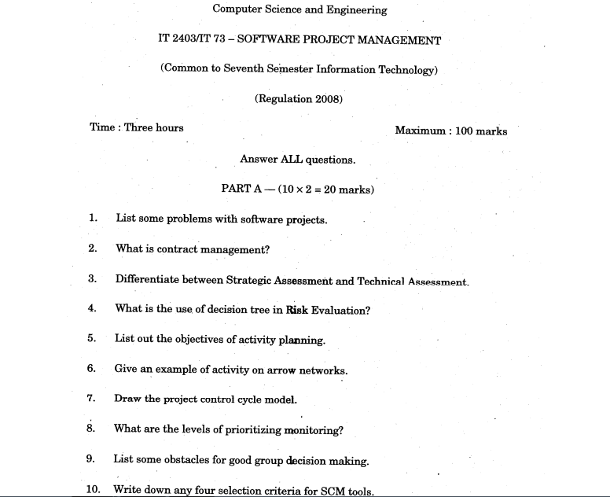

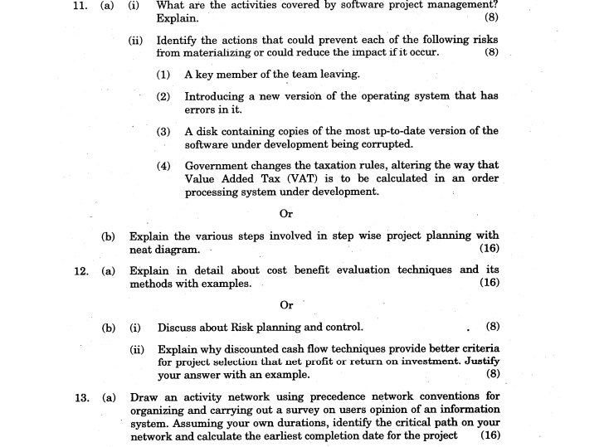


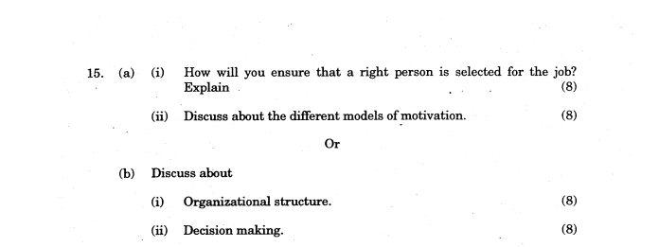

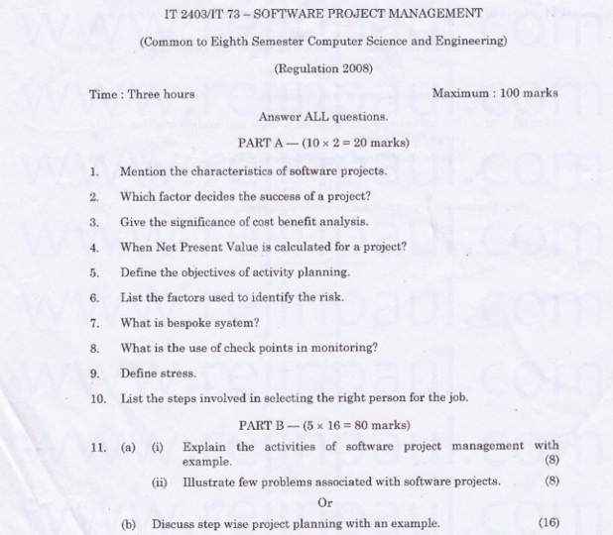

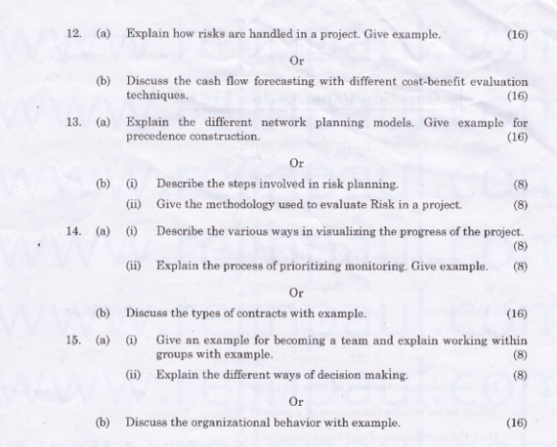

Tutorial Sheet
Unit-I
Topics Revised | Date:
Unit-II
Topics Revised | Date:
Unit-III
Topics Revised | Date:
Unit-IV
Topics Revised | Date:
Unit-V
Topics Revised | Date:

TOPICS BEYOND SYLLABUS

Unit – 1
1. | Requirement Elicitation
2. | Requirement Analysis

ASSESMENT OF OUT COMES: DIRECT
Blooms Taxonomy:
LEVEL 1 | REMEMBERING | Exhibit memory of previously learned material by recalling facts, terms, basic concepts, and answers
LEVEL 2 | UNDERSTANDING | Demonstrate understanding of facts and ideas by organizing, comparing, translating, interpreting, giving descriptions, and stating main ideas.
LEVEL 3 | APPLYING | Solve problems to new situations by applying acquired knowledge, facts, techniques and rules in a different way
LEVEL 4 | ANALYZING | Examine and break information into parts by identifying motives or causes. Make inferences and find evidence to support generalizations.
LEVEL 5 | EVALUATING | Present and defend opinions by making judgments about information, validity of ideas, or quality of work based on a set of criteria.
LEVEL 6 | CREATING | Compile information together in a different way by combining elements in a new pattern or proposing alternative solutions.

ASSESMENT OF COURSE OUTCOMES: INDIRECT

CSP Rubric
S.N0 | Criteria | LEVEL ( Level : 3-Excellent Level :2-Good Level : 1-Poor)
1 | Oral Communication | 3 | Student speaks in phase with the given topic confidently using Audio-Visual aids. Vocabulary is good
1 | Oral Communication | 2 | Student speaking without proper planning, fair usage of Audio-Visual aids. Vocabulary is not good
1 | Oral Communication | 1 | Student speaks vaguely not in phase with the given topic. No synchronization among the talk and Visual Aids
2 | Writing Skills | 3 | Proper structuring of the document with relevant subtitles, readability of document is high with correct use of grammar. Work is genuine and not published anywhere else
2 | Writing Skills | 2 | Information is gathered without continuity of topic, sentences were not framed properly. Few topics are copied from other documents
2 | Writing Skills | 1 | Information gathered was not relevant to the given task, vague collection of sentences. Content is copied from other documents
3 | Social and Ethical Awareness | 3 | Student identifies most potential ethical or societal issues and tries to provide solutions for them discussing with peers
3 | Social and Ethical Awareness | 2 | Student identifies the societal and ethical issues but fails to provide any solutions discussing with peers
3 | Social and Ethical Awareness | 1 | Student makes no attempt in identifying the societal and ethical issues
4 | Content Knowledge | 3 | Student uses appropriate methods, techniques to model and solve the problem accurately
4 | Content Knowledge | 2 | Student tries to model the problem but fails to solve the problem
4 | Content Knowledge | 1 | Student fails to model the problem and also fails to solve the problem
5 | Student Participation | 3 | Listens carefully to the class and tries to answer questions confidently
5 | Student Participation | 2 | Listens carefully to the lecture but doesn’t attempt to answer the questions
5 | Student Participation | 1 | Student neither listens to the class nor attempts to answer the questions
6 | Technical and analytical Skills | 3 | The program structure is well organized with appropriate use of technologies and methodology. Code is easy to read and well documented. Student is able to implement the algorithm producing accurate results
6 | Technical and analytical Skills | 2 | Program structure is well organized with appropriate use of technologies and methodology. Code is quite difficult to read and not properly documented. Student is able to implement the algorithm providing accurate results.
6 | Technical and analytical Skills | 1 | Program structure is not well organized with mistakes in usage of appropriate technologies and methodology. Code is difficult to read and student is not able to execute the program
7 | Practical Knowledge | 3 | Independently able to write programs to strengthen the concepts covered in theory
7 | Practical Knowledge | 2 | Independently able to write programs but not able to strengthen the concepts learned in theory
7 | Practical Knowledge | 1 | Not able to write programs and not able to strengthen the concepts learned in theory
8 | Understanding of Engineering core | 3 | Student uses appropriate methods, techniques to model and solve the problem accurately in the context of multidisciplinary projects
8 | Understanding of Engineering core | 2 | Student tries to model the problem but fails to solve the problem in the context of multidisciplinary projects
8 | Understanding of Engineering core | 1 | Student fails to model the problem and also fails to solve the problem in the context  of multidisciplinary projects

Course assessment sheet Indirect:
CSP Rubric Name & Number:

Add-on Programmers (Guest Lecture/Video Lecture/Poster Presentation):
1.

2

Unit Wise PPT’s & Lecture Notes

-----****-----

